TEAM FRENCH CONNECTION



**Team members:**

**Goran91 - Горан Цветков**

**baretata - Златко Атанасов**

**Mask_ln - Любомир Нанев**

**stoberov - Стоян Беров**

**KrasiKoziroga - Красимир Стоянов**

**PaperNick - Николай Павлов**

**SvetlaPetkova - Светла Петкова**

Team Project: PUZZLE MASTER

The game:

The game is a browser game where players can spend their spare time solving puzzled images. The players can choose from 3 options:

* uploading their own image;
* provide URL with image from the Internet;
* pick a image from the application gallery;

The puzzle game has 5 levels of difficulty (from separation 3x3 per row and column to 7x7).When shuffled, some pieces do not only change their original position, but there is a chance they rotate at 180°.The player can drag and drop the pieces in order to solve the puzzle and can double click on a piece that should be rotated to its original state.

The puzzle has a timer starting to count when the player clicks the “Start Puzzle” button and when the player solves the puzzle, an alert pops up and inform the user about his score (time).

Structure of the application:

**Index page** – The index page of the application has a brief information about the game. It provides a link to the project's github repository. It has a logo animated with SVG and a button “Start Playing” that takes the user to the next page where the game begins.

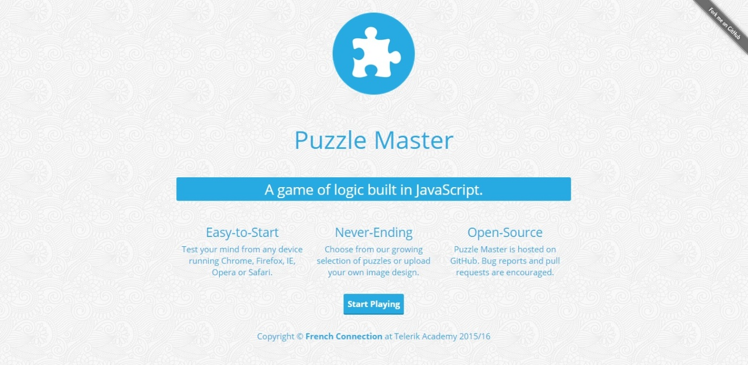

**Image 1:** *Index page*

**\* The loading translation from Index page to Puzzle page is animated with SVG.**

**Puzzle page** – The puzzle page of the application is separated into panels.

The first panel is the canvas where the user solves the puzzled image.

The second panel is the user control panel where the player can choose from where to get his image for the puzzle (upload, URL, gallery).The panel also contains “Select difficulty” dropdown menu where the player can choose the difficulty of the puzzle. Next feature in this panel is the timer which counts the time that player has spend solving the given puzzle. Lastly the panel contains “Set” button that has to be clicked after the player has set his exact options for the game. After hitting “Set” the options are saved and the player can hit “Start Puzzle”, and the game begins.

The third panel is the gallery panel. This panel is hidden unless the user clicks the “Choose from gallery” button. If clicked the panel shows below the first panel and the player can browse and pick an image from the gallery panel.

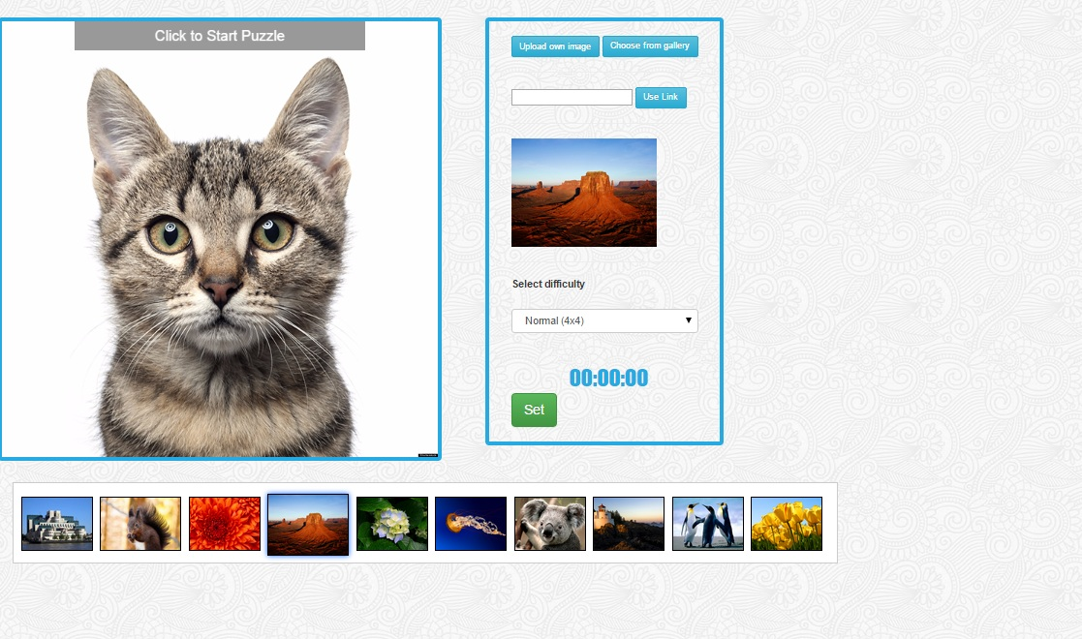

**Image 2**: *Puzzle page*

Implemented features:

* HTML5 Canvas
* SVG
* Animations created with SVG
* Cross - browser

Additional implemented features:

* Used native DOM manipulations
* Used libraries: jQuery, Bootstrap
* Best practices and high-quality code principles
* Used OOP, modules and data encapsulation
* Strong cohesion and loose coupling

**GitHub**: <https://github.com/KrasiStoyanov/JS-UI-And-DOM-Team-FrenchConnection>